**INFO-5146-02**

**Git and Git hub lab**

URL to my repository:

<https://github.com/lungma15/AL.git>

Screenshot of the command prompt output when I push to my repo:

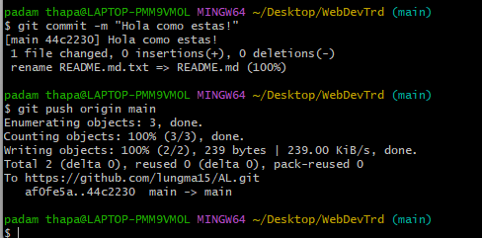

Screenshot of repo file with my repo name:

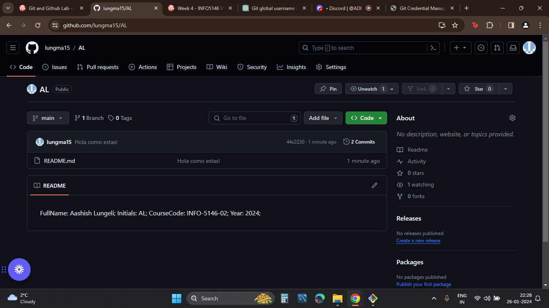

**Aashish Lungeli (AL)**